CS 255 System Design Document Template

UML Diagrams

UML Use Case Diagram
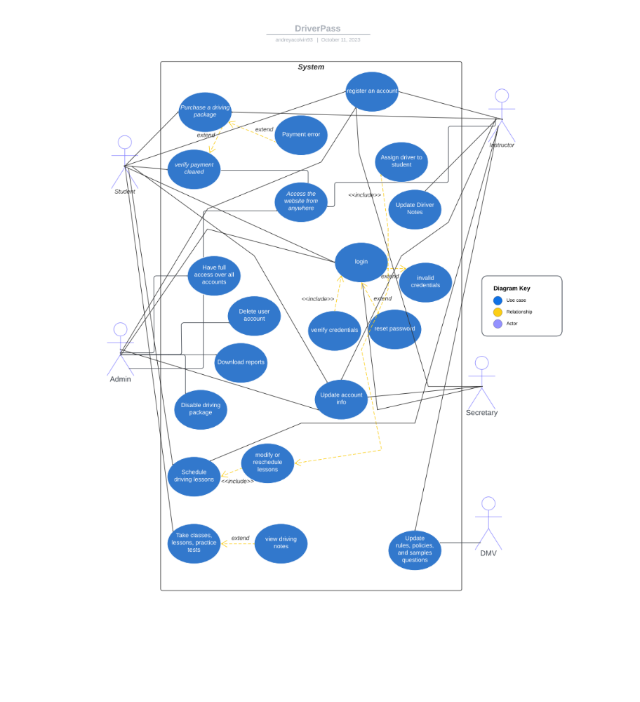

UML Activity Diagrams
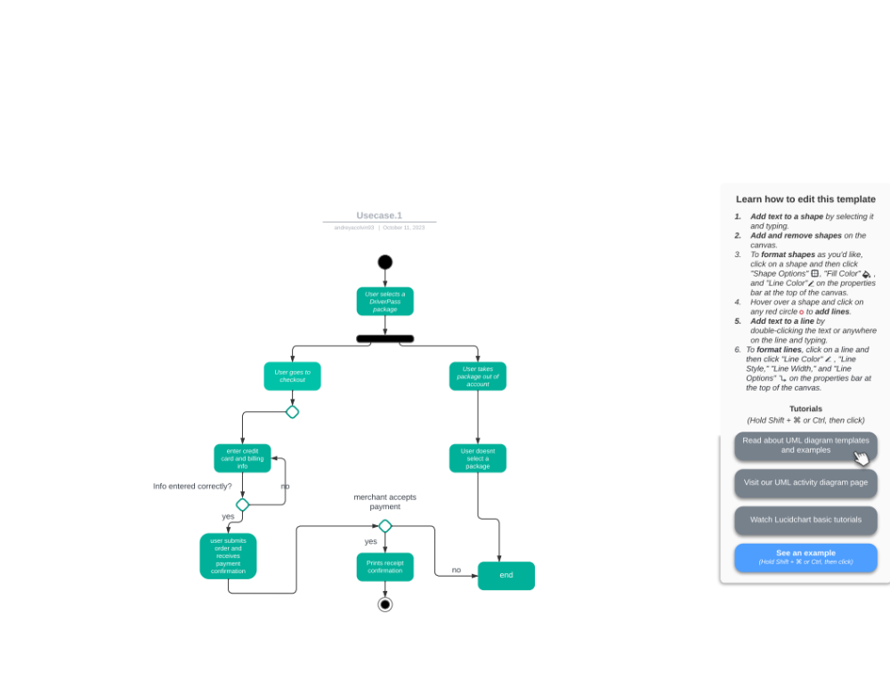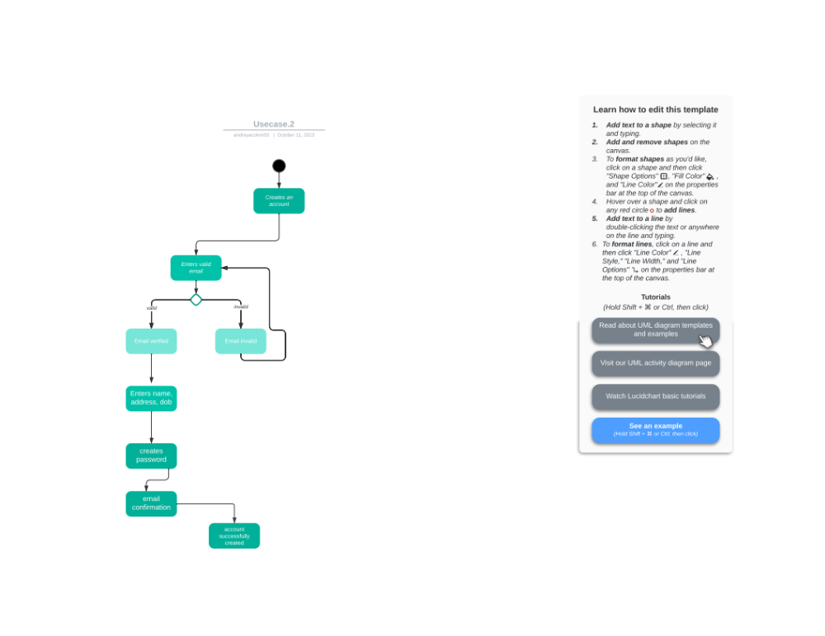

UML Sequence Diagram
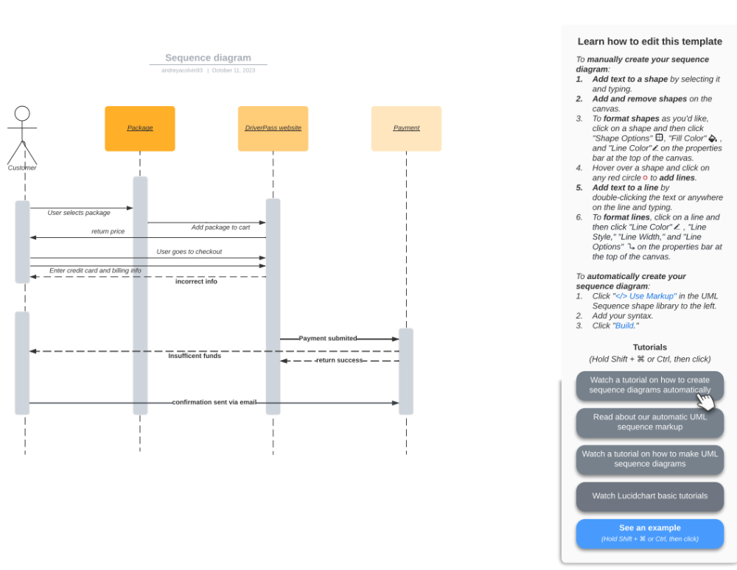

UML Class Diagram
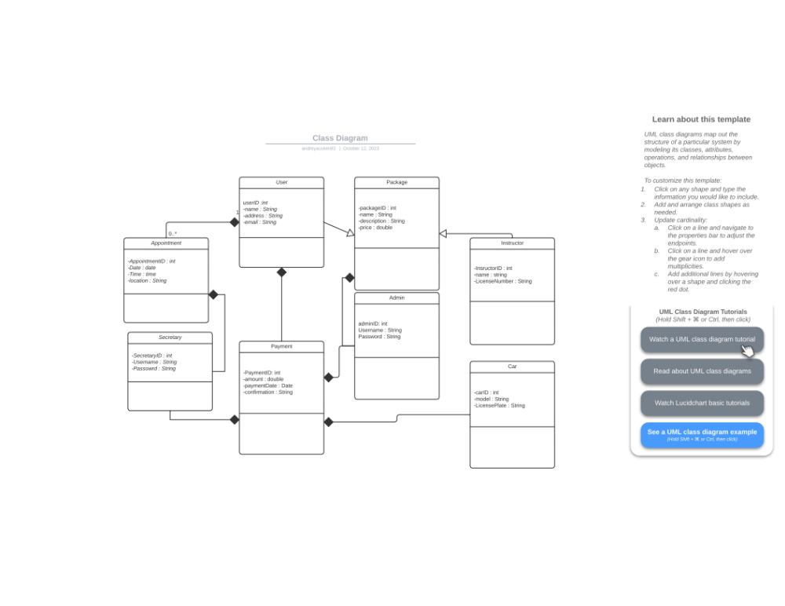

Technical Requirements

Hardware requirements include:
- Server infrastructure for hosting the DriverPass system.
- Database server to store the user’s data.
- Network infrastructure for data to communicate to the server.
- Devices for the users, admin, secretary, and DMV policy holders.
Software requirements include:
- Web application software that all users can access through the web.
- Data base management system for database and storage.
- Security software to ensure the protection of the software and user identification.
- Operating system for the server.
Tools and infrastructure requirements include:
- IDE (integrated development environment) for development.
- ULM modeling tools for documentation and system design.
- Internet connectivity to access the system.
- Cloud hosting services for scalability.

